iStudio
Name: Ayush Kumar
Assignment number: 1
Course / Internship name: Data Analytics Internship
Task 1:
Excel file showing the formatted dataset, total_amount column, 7 calculated function values, and the 3 charts
Chart 1 (Bar graph)

Chart 2 (Pie chart)

Chart 3 (Line graph)

Formula table
# | Label Text | Excel Formula
1. | Total Revenue: | =SUM(H2:H16)
2. | Average Sale: | =AVERAGE(H2:H16)
3 | Maximum Sale: | =MAX(H2:H16)
4. | Minimum Sale: | =MIN(H2:H16)
5. | Fashion Sales Count: | =COUNTIF(C2:C16, "Fashion")
6. | Electronics Revenue: | =SUMIF(C2:C16, "Electronics", H2:H16)
7. | Bonus | =IF(H2>50000, "High", "Normal")

Task 2:
Screenshots of 3 Pivot Tables, 1 Pivot Chart, and the Slicer in use.
Pivot table 1:
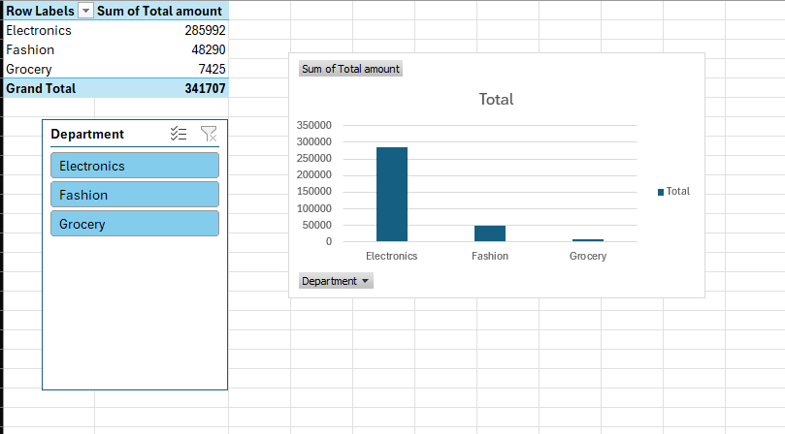

Pivot table 2:
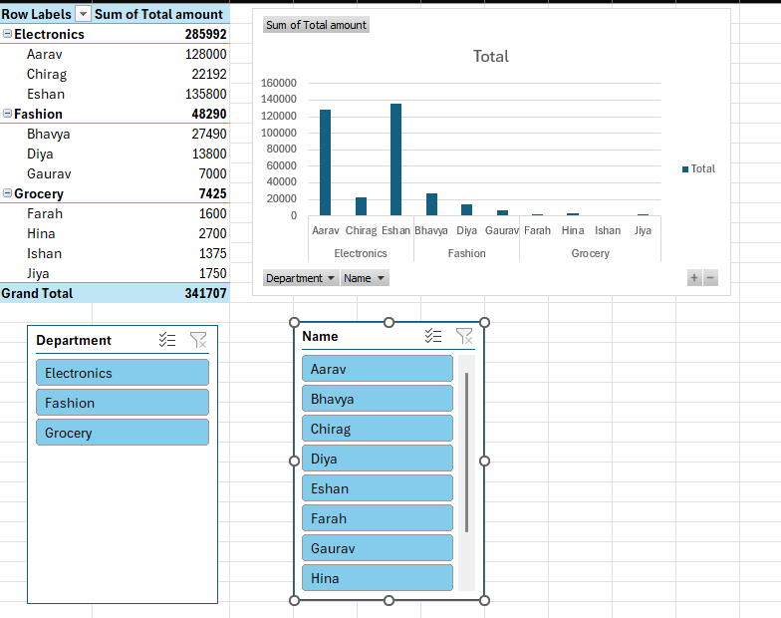
Pivot table 3:
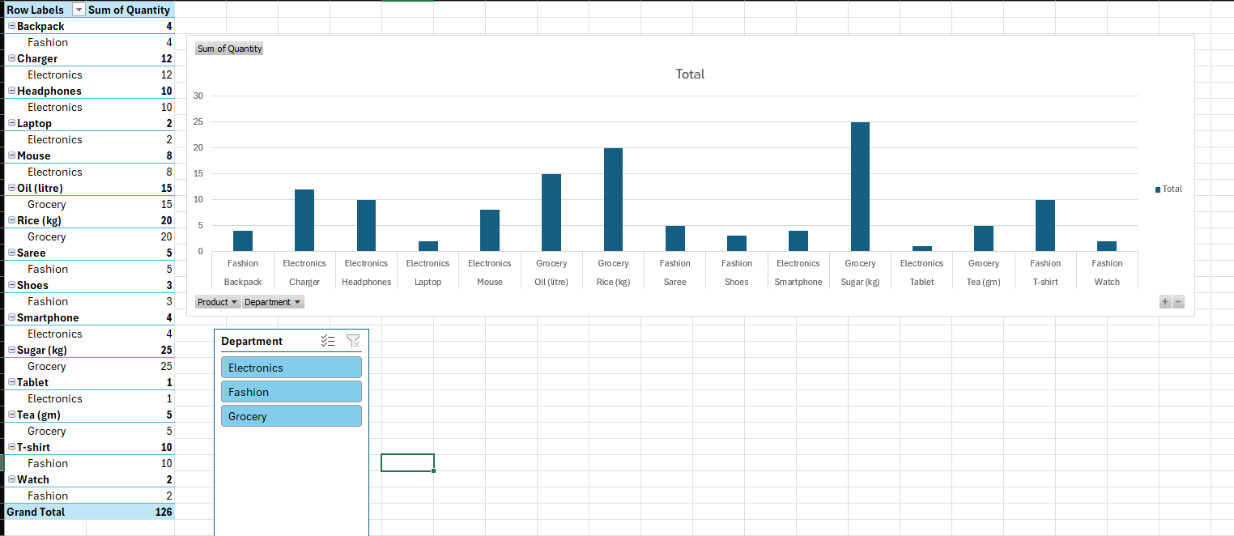

Task 3:
All 10 SQL queries plus 3 CRUD statements with their outputs.
Sql query 1
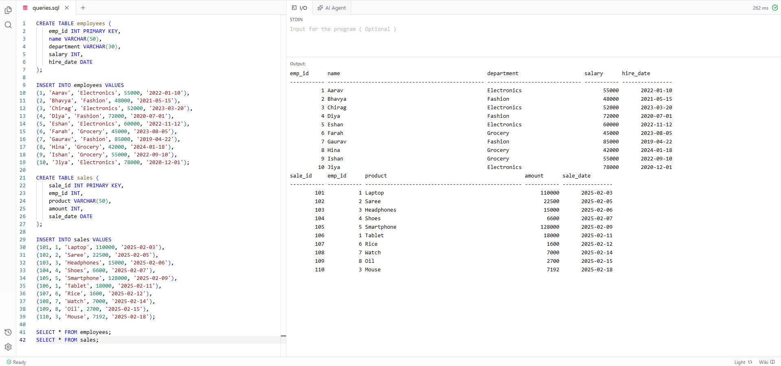
Sql query 2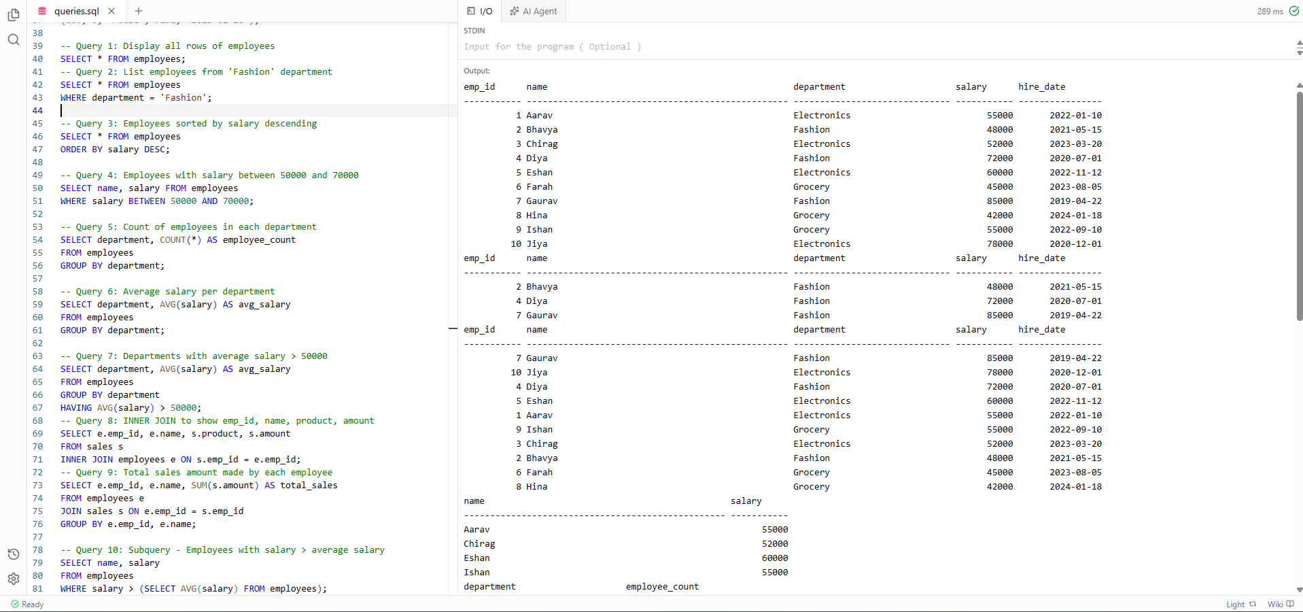
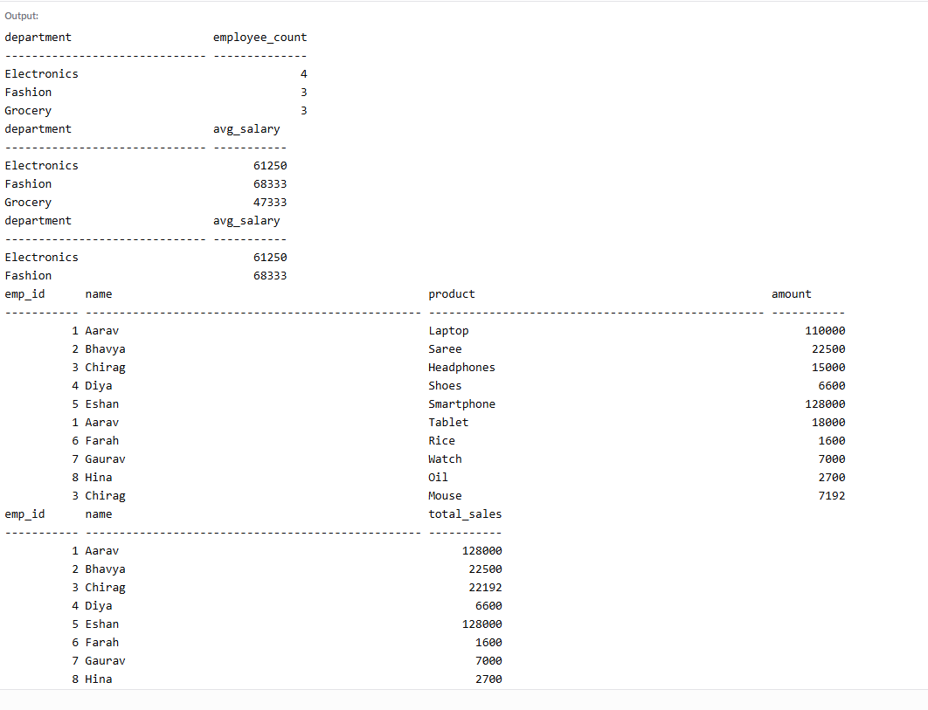
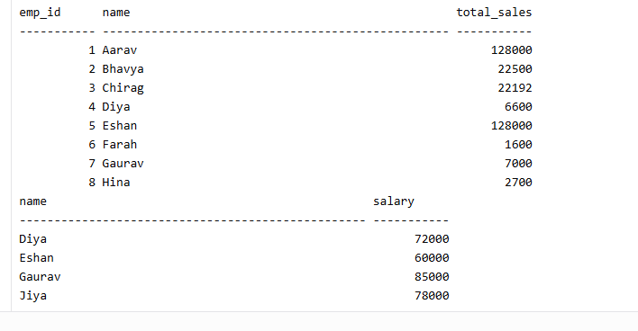

Sql query 3
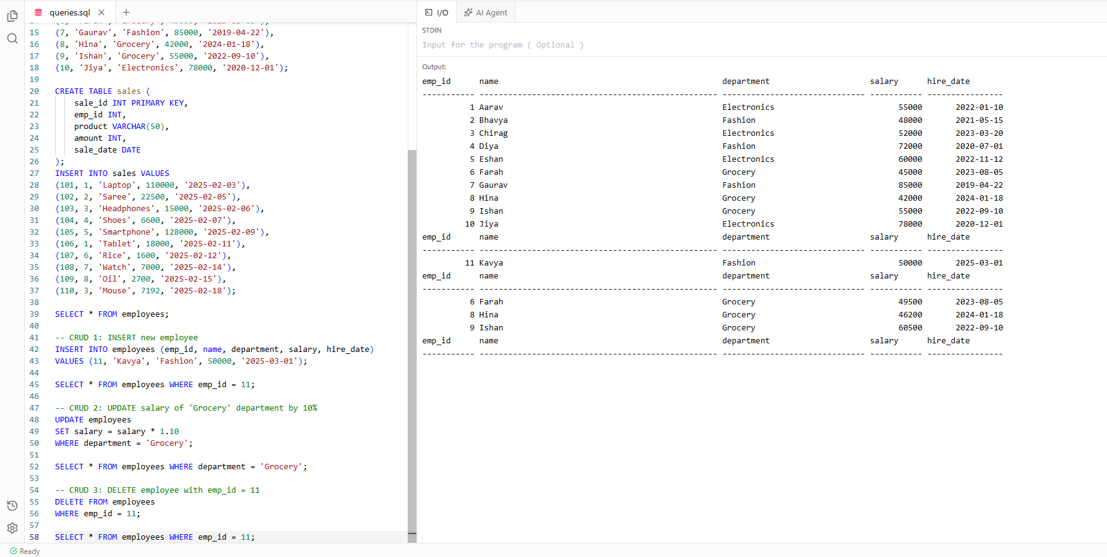

SQL Queries:
-- Database Setup
CREATE TABLE employees (
emp_id INT PRIMARY KEY,
name VARCHAR(50),
department VARCHAR(30),
salary INT,
hire_date DATE
);
INSERT INTO employees VALUES
(1, 'Aarav', 'Electronics', 55000, '2022-01-10'),
(2, 'Bhavya', 'Fashion', 48000, '2021-05-15'),
(3, 'Chirag', 'Electronics', 52000, '2023-03-20'),
(4, 'Diya', 'Fashion', 72000, '2020-07-01'),
(5, 'Eshan', 'Electronics', 60000, '2022-11-12'),
(6, 'Farah', 'Grocery', 45000, '2023-08-05'),
(7, 'Gaurav', 'Fashion', 85000, '2019-04-22'),
(8, 'Hina', 'Grocery', 42000, '2024-01-18'),
(9, 'Ishan', 'Grocery', 55000, '2022-09-10'),
(10, 'Jiya', 'Electronics', 78000, '2020-12-01');

CREATE TABLE sales (
sale_id INT PRIMARY KEY,
emp_id INT,
product VARCHAR(50),
amount INT,
sale_date DATE
);
INSERT INTO sales VALUES
(101, 1, 'Laptop', 110000, '2025-02-03'),
(102, 2, 'Saree', 22500, '2025-02-05'),
(103, 3, 'Headphones', 15000, '2025-02-06'),
(104, 4, 'Shoes', 6600, '2025-02-07'),
(105, 5, 'Smartphone', 128000, '2025-02-09'),
(106, 1, 'Tablet', 18000, '2025-02-11'),
(107, 6, 'Rice', 1600, '2025-02-12'),
(108, 7, 'Watch', 7000, '2025-02-14'),
(109, 8, 'Oil', 2700, '2025-02-15'),
(110, 3, 'Mouse', 7192, '2025-02-18');

10 Sql Queries:
-- Query 1: Display all rows of employees
SELECT * FROM employees;

-- Query 2: List employees from 'Fashion' department
SELECT * FROM employees
WHERE department = 'Fashion';

-- Query 3: Employees sorted by salary descending
SELECT * FROM employees
ORDER BY salary DESC;

-- Query 4: Employees with salary between 50000 and 70000
SELECT name, salary FROM employees
WHERE salary BETWEEN 50000 AND 70000;

-- Query 5: Count of employees in each department
SELECT department, COUNT(*) AS employee_count
FROM employees
GROUP BY department;

-- Query 6: Average salary per department
SELECT department, AVG(salary) AS avg_salary
FROM employees
GROUP BY department;

-- Query 7: Departments with average salary > 50000
SELECT department, AVG(salary) AS avg_salary
FROM employees
GROUP BY department
HAVING AVG(salary) > 50000;

-- Query 8: INNER JOIN to show emp_id, name, product, amount
SELECT e.emp_id, e.name, s.product, s.amount
FROM sales s
INNER JOIN employees e ON s.emp_id = e.emp_id;

-- Query 9: Total sales amount made by each employee
SELECT e.emp_id, e.name, SUM(s.amount) AS total_sales
FROM employees e
JOIN sales s ON e.emp_id = s.emp_id
GROUP BY e.emp_id, e.name;

-- Query 10: Subquery - Employees with salary > average salary
SELECT name, salary
FROM employees
WHERE salary > (SELECT AVG(salary) FROM employees);

3 CRUD Operations:
-- CRUD 1: INSERT new employee
INSERT INTO employees (emp_id, name, department, salary, hire_date)
VALUES (11, 'Kavya', 'Fashion', 50000, '2025-03-01');

SELECT * FROM employees WHERE emp_id = 11;

-- CRUD 2: UPDATE salary of 'Grocery' department by 10%
UPDATE employees
SET salary = salary * 1.10
WHERE department = 'Grocery';

SELECT * FROM employees WHERE department = 'Grocery';

-- CRUD 3: DELETE employee with emp_id = 11
DELETE FROM employees
WHERE emp_id = 11;

SELECT * FROM employees WHERE emp_id = 11;

SQL Queries (Task 3.1):
# | Task / Query Description | SQL Query
1 | Display all rows of the employees table | SELECT * FROM employees;
2 | List employees from the 'Fashion' department only | SELECT * FROM employees WHERE department = 'Fashion';
3 | Display all employees sorted by salary in descending order | SELECT * FROM employees ORDER BY salary DESC;
4 | Display names of employees with salary between 50000 and 70000 | SELECT name, salary FROM employees WHERE salary BETWEEN 50000 AND 70000;
5 | Find the total number of employees in each department | SELECT department, COUNT(*) AS employee_count FROM employees GROUP BY department;
6 | Find the average salary per department | SELECT department, AVG(salary) AS avg_salary FROM employees GROUP BY department;
7 | Find departments where average salary is greater than 50000 | SELECT department, AVG(salary) AS avg_salary FROM employees GROUP BY department HAVING AVG(salary) > 50000;
8 | INNER JOIN to show emp_id, name, product, and amount for all sales | SELECT e.emp_id, e.name, s.product, s.amount FROM sales s INNER JOIN employees e ON s.emp_id = e.emp_id;
9 | Find total sales amount made by each employee | SELECT e.emp_id, e.name, SUM(s.amount) AS total_sales FROM employees e JOIN sales s ON e.emp_id = s.emp_id GROUP BY e.emp_id, e.name;
10 | Subquery to find employees with salary greater than average salary | SELECT name, salary FROM employees WHERE salary > (SELECT AVG(salary) FROM employees);

CRUD Operations (Task 3.2):
# | Operation | SQL Statement | Verification Query
1 | INSERT: Add employee (emp_id=11, Kavya, Fashion, 50000, 2025-03-01) | INSERT INTO employees (emp_id, name, department, salary, hire_date) VALUES (11, 'Kavya', 'Fashion', 50000, '2025-03-01'); | SELECT * FROM employees WHERE emp_id = 11;
2 | UPDATE: Increase salary of 'Grocery' department by 10% | UPDATE employees SET salary = salary * 1.10 WHERE department = 'Grocery'; | SELECT * FROM employees WHERE department = 'Grocery';
3 | DELETE: Remove employee with emp_id=11 | DELETE FROM employees WHERE emp_id = 11; | SELECT * FROM employees WHERE emp_id = 11;

